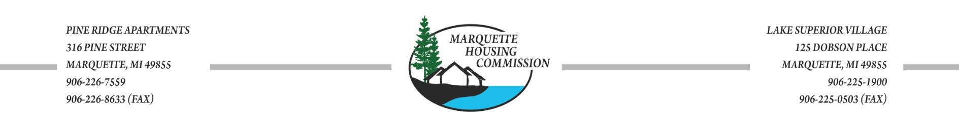
PRE-APPLICATION FOR HOUSING ASSISTANCE

Head of Household (HOH) Name:

Alias/Maiden Name:

Do you need assistance to complete this application (reasonable accommodation) or an interpreter? Y / N

If yes, please explain or contact our office:

Current Address:
(Street) (City) (State) (Zip code)

Phone Number: E-mail: Text:

INCOMPLETE INFORMATION WILL DELAY THE PROCESSING OF YOUR APPLICATION

Household Members: Please list all adults and children who will be living in the household including, live-in aides, foster children, and foster adults. Please attach an additional page if necessary.
Full Legal Name  (Also include alias or maiden name) | Relation to HOH | Social Security Number | Date of Birth | Sex | Age | Race | Do you claim a disability | US  Veteran/  Spouse of Veteran | US Citizen | Full time Student
 | Self |  |  |  |  |  | Y / N | Y / N | Y / N | Y / N
 |  |  |  |  |  |  | Y / N | Y / N | Y / N | Y / N
 |  |  |  |  |  |  | Y / N | Y / N | Y / N | Y / N
 |  |  |  |  |  |  | Y / N | Y / N | Y / N | Y / N
 |  |  |  |  |  |  | Y / N | Y / N | Y / N | Y / N

Household Income: (Do NOT include any income that would be lost when relocating to Marquette Housing Commission.)
HOUSEHOLD MEMBER  Full Legal Name | SOURCE OF INCOME  Social Security, SSI/SSDI, Employer, etc. | WAGE  Hourly | HOURS WORKED | TOTAL INCOME
 |  |  | Weekly Bi-Weekly Monthly  / / | Weekly Bi-Weekly Monthly  / /
 |  |  | Weekly Bi-Weekly Monthly  / / | Weekly Bi-Weekly Monthly  / /
 |  |  | Weekly Bi-Weekly Monthly  / / | Weekly Bi-Weekly Monthly  / /

Qualifying Income Limits:

Family Size | 1 | 2 | 3 | 4 | 5 | 6 | 7 | 8
Low-Income | 33,950 | 38,800 | 43,650 | 48,500 | 52,400 | 56,300 | 60,150 | 64,050

- Does the Head of Household or Co-head of Household have a Payee? Y / N

If yes, please provide name and phone number:

Payee’s Address:

- Does the Head of Household or Co-head of Household have a Legal Guardian? Y / N

If yes, please provide name and phone number:

Guardian’s Address:

- Are you or any household members currently a medical marijuana card holder or applying for one? Y / N

- Do any household members need a barrier free unit? Y / N
- Is your household currently homeless? Y / N

If yes, where are you sleeping?

- Has any household member been convicted of any felonies within the last 5 years? Y / N

- Are any household members a registered sex offender? Y / N
(This information will be verified through the U.S. Department of Justice National Sex Offender Registry)

- Is the Head of Household or Co-head of Household fleeing domestic violence? Y / N

- Does the Head of Household or Co-head of Household have a court ordered reunification plan with one or more children who will be living in the household? Y / N

- Does your household plan to have anyone living with you who is not listed above? Y / N
*This includes any unborn children.
If yes, please explain:

Warning: 18 U.S.C. 1001 provides, among other things, that whoever knowingly and willfully makes or uses a document or writing containing any false, fictitious, or fraudulent statement or entry, in any matter within the jurisdiction of any department or agency of the United States, shall be fined not more than $10,000 or imprisoned for not more than five years, or both.
Consent: I consent to allow the Marquette Housing Commission to verify my landlord references, income, assets, and expenses. I also consent to allow MHC to screen for eligibility my credit and criminal history. I certify that the above information is a complete and true statement of family composition, income, employment, and assets to the best of my knowledge and belief.

Head of Household/Guardian Signature Date

Spouse/Co-Head Signature Date

Other Adult Signature Date
FOR OFFICE USE ONLY:

Higher Income $300+ (10) Higher Income $200+ (8) Elderly (7)

Disabled (7) Works 30+ (4) Near-Elderly (3)

Veteran/Spouse (3) Works 20-29 (3) City of Mqt (2)

Domestic Violence (1) Child Reunification (1) Homeless (1)

Handicap Accessible (0)

